**Manage Restaurant**

* Back-end: Java Spring boot, SQL Server

SQL diagram:

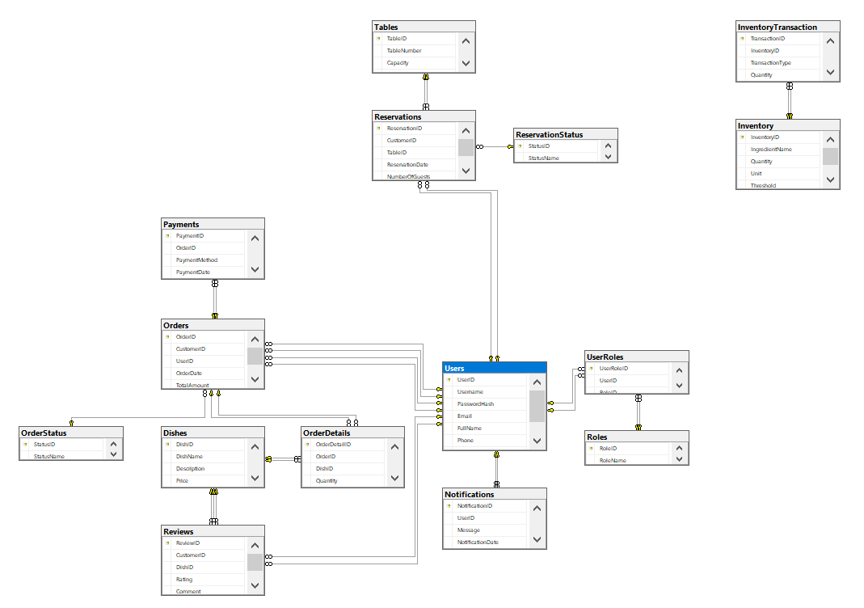

* Front-end: React-native

User interface:

